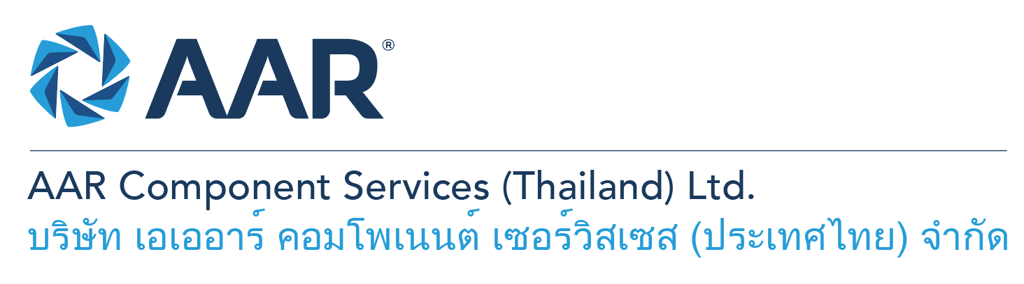

**Senior Logistics Officer**

**Quick AAR information / resources**

**Website:** [aarcorp.com](https://www.aarcorp.com/)

**Careers:** [aarcorp.com/careers](https://www.aarcorp.com/careers/)

**Email:** ACSTH-Recruitment@aarcorp.com

**The position**

**Key Roles & Responsibilities:**

* Liaise with Government involved in import/ export, privileges, permits and licenses to be aligned with its regulation.
* Coordinate with Engineering and prepare material list for Customs declaration.
* To co-ordinate with local suppliers and prepare Customs documentation for local purchases with Zero percent VAT.
* Prepare letter and related documents for Regulations approval process.
* Perform imports and exports documents.
* Control the import & export material list base on approved master list by Regulations.
* Obtain the approval of import duty and VAT free.
* Perform Customs Formality and Freight Arrangement.
* Perform all Import, Export Shipments and Freight Arrangement based on PO Shipping Terms or e-LSR Requirement with maximize benefit, cost and delivery.
* Review the shipping document e.g. Performa Invoice, Packing List, and Bill of Lading (B/L) & Air Waybill (AWB).
* Issue Work Orders to Logistics/Transportation providers.
* Process and verify all related invoices to logistics activities.
* Prepare documentation for Process of Country-of-Origin Certificate (COC) to client.
* Maintain / reconcile material list against the master list.

**Qualifications:**

* Bachelor’s degree or equivalent work experience required.
* Experiences 5+ years in export / import with a freight forwarding company.
* Good English language skills.
* Good command in MS-office (Excel, Word, and Outlook).
* Able to multi-task with positive attitude and enthusiastic personality.
* Able to work under pressure and flexible hours.
* Detailed and careful with paperwork.

- Result oriented and able to meet deadlines.

**Total rewards**

As an AAR team member your rewards include:

* Annual uniform
* PPE safety equipment
* Transportation
* Vacation benefits, including Thai Public Holidays
* Provident Fund
* Group Insurance
* Training and development opportunities
* Staff engagement and recognition events

**Performance objectives**

* **Teamwork** – collaborates with colleagues to achieve results and is also comfortable working independently
* **Building trust** – operates with integrity, discloses own positions, remains open to ideas, and supports others through dignity, respect, and fairness
* **Building relationships and partnerships** – develops and leverages relationships within and across teams to achieve results
* **Communication** – conveys information and ideas clearly and concisely to individuals or group in an engaging manner, helping them understand and retain the message
* **Analytical skills** – must be able to use data to determine cause and effect for complex problem solving
* **Quality orientation** – accomplishes tasks by considering all areas involved, no matter how detailed

**Why should you apply?**

* AAR is the only aerospace / defense company on Forbes’ America’s Best Mid-Size Employers list.
* Our innovative and entrepreneurial culture encourages employee input in every aspect, from day-to-day activities to the company’s future growth.
* Our learning and career development program affords employees a learning path with the necessary tools and resources needed to help build their career at AAR.
* We support non-profits and organizations that work to improve society in four primary areas: veterans and active military; education with an emphasis on STEM; health and wellness; and diversity / inclusion.

**About AAR**

AAR is an awarded global aerospace and defense company that offers employees a long-term career pathway and the opportunity to work with a great team! At AAR, our people remain our priority! We create the #BestTeamInAviation by focusing on recruitment, training, growth, engagement, and retention. AAR employees are empowered to meet their individual professional development goals through our global learning and development program, mentorship program, leadership training, continued education, networking, and much more!

AAR is committed to building a diverse and inclusive workforce. We encourage applications from people of all races, ethnic origins, religions, abilities, sexual orientations, gender identities, or expressions. We are dedicated to the health and safety of our people, our customers, and the communities where we live and work.

**Primary Location**: 700/160 Amata City Chonburi Industrial Estate Moo1, T. Bankao, A. Pantong, Chonburi, 20160 Thailand.

Qualified applicants may email their resume to [ACSTH-Recruitment@aarcorp.com](mailto:ACSTH-Recruitment@aarcorp.com)

Please submit your resume in PDF format.

Although all applications are appreciated, only those candidates selected for an interview will be contacted.