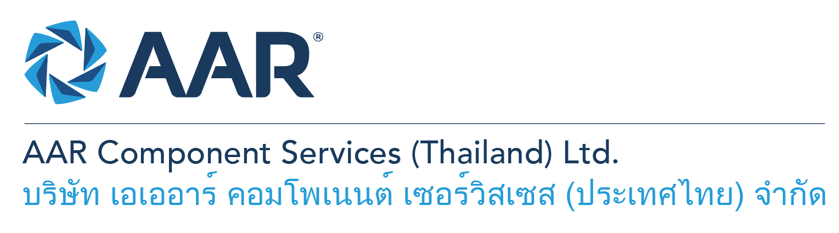

**Production Planner & Expeditor**

**Quick AAR information / resources**

**Website:** [aarcorp.com](https://www.aarcorp.com/)

**Careers:** [aarcorp.com/careers](https://www.aarcorp.com/careers/)

**Email:** ACSTH-Recruitment@aarcorp.com

**The position**

We are looking for Production Planner & Expeditor. Production Planner & Expeditor is responsible for performing a wide variety of administrative production support duties to keep the process flow with problem solving skills to minimize waiting times in productions and also planning with repair center team leads for estimated completion dates and preparing production schedules.

**Key Roles & Responsibilities:**

* Daily run through production gate report for SRO status and progress.
* Daily follow up with Design, Production and Process engineers on pending instruction and routings.
* Daily check completion of repair instructions and routings of quote approved SROs prior to inducting to repair processes.
* Coordinate with repair center team leads and planners for repair completion dates and material clear dates and prepare repaired parts, material replacement, hardware and chemical to be ready on the shelves for assembly process.
* Immediately alert to team leads and program manager when non-conformances or delays in production schedule are found.
* Collect repair/maintenance records (DRs and routings) and put in SRO work binders.
* Receive and check aircraft parts issued from store and deliver to proper order shelves.
* Manage and maintain floor stock items within product lines.
* Coordinate with STR team leader to coordinate the “Loan”, “Internal Item Transfer” of the material, parts, and end items as required.
* Open service repair order (SRO) in Syteline (ERP).
* Track Air Waybills of materials for arrival dates.
* Pull Transactions in Syteline and develop a plan cost.
* Issue Purchase Order Requisition as requested by production personnel.
* Monitor/Control calibrated tools/equipments to ensure they are valid at all times.
* Support production on exporting document such as Export requisition form and take photos prior to sending parts to store.
* Take photo all scrapped and OP parts and also create scrapped part lists for closed SROs and send parts to MRB/Scrap Room

**Qualifications:**

* High vocational diploma with background and experience in production or Bachelor’s Degree
* Ability to coordinate and work well with other departments and individuals within organization.
* Strong Teamwork ethic, communication and interpersonal skills
* Good attitude and always have service mind.
* Respectful of the opinions of others
* Proficiency in computer skills (MS Work, Office, Excel).
* Ability to read, write and understand English and computer literacy is required.
* Willing to learn and self-motivated.

**Total rewards**

As an AAR team member your rewards include:

* Annual uniform
* PPE safety equipment
* Transportation
* Vacation benefits, including Thai Public Holidays
* Provident Fund
* Group Insurance
* Training and development opportunities
* Staff engagement and recognition events

**Performance objectives**

* **Teamwork** – collaborates with colleagues to achieve results and is also comfortable working independently
* **Building trust** – operates with integrity, discloses own positions, remains open to ideas, and supports others through dignity, respect, and fairness
* **Building relationships and partnerships** – develops and leverages relationships within and across teams to achieve results
* **Communication** – conveys information and ideas clearly and concisely to individuals or group in an engaging manner, helping them understand and retain the message
* **Analytical skills** – must be able to use data to determine cause and effect for complex problem solving
* **Quality orientation** – accomplishes tasks by considering all areas involved, no matter how detailed

**Why should you apply?**

* AAR is the only aerospace / defense company on Forbes’ America’s Best Mid-Size Employers list.
* Our innovative and entrepreneurial culture encourages employee input in every aspect, from day-to-day activities to the company’s future growth.
* Our learning and career development program affords employees a learning path with the necessary tools and resources needed to help build their career at AAR.
* We support non-profits and organizations that work to improve society in four primary areas: veterans and active military; education with an emphasis on STEM; health and wellness; and diversity / inclusion.

**About AAR**

AAR is an awarded global aerospace and defense company that offers employees a long-term career pathway and the opportunity to work with a great team! At AAR, our people remain our priority! We create the #BestTeamInAviation by focusing on recruitment, training, growth, engagement, and retention. AAR employees are empowered to meet their individual professional development goals through our global learning and development program, mentorship program, leadership training, continued education, networking, and much more!

AAR is committed to building a diverse and inclusive workforce. We encourage applications from people of all races, ethnic origins, religions, abilities, sexual orientations, gender identities, or expressions. We are dedicated to the health and safety of our people, our customers, and the communities where we live and work.

**Primary Location**: 700/160 Amata City Chonburi Industrial Estate Moo1, T. Bankao, A. Pantong, Chonburi, 20160 Thailand.

Qualified applicants may email their resume to [ACSTH-Recruitment@aarcorp.com](mailto:ACSTH-Recruitment@aarcorp.com)

Please submit your resume in PDF format.

Although all applications are appreciated, only those candidates selected for an interview will be contacted.