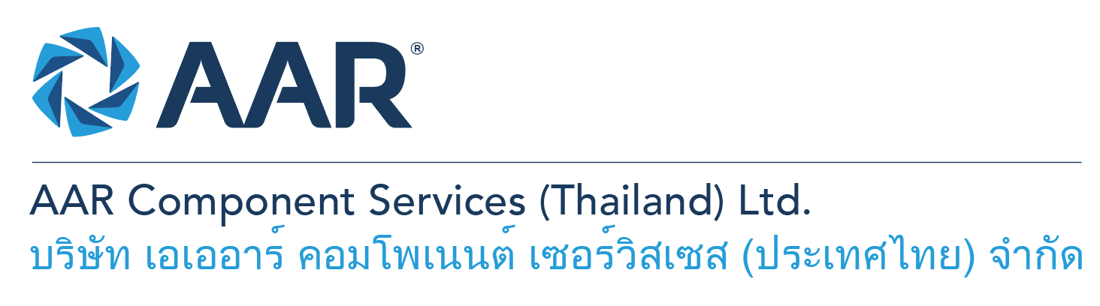

**Production Engineer (Nacelles)**

**Quick AAR information / resources**

**Website:** [aarcorp.com](https://www.aarcorp.com/)

**Careers:** [aarcorp.com/careers](https://www.aarcorp.com/careers/)

**Email:** ACSTH-Recruitment@aarcorp.com

**The position**

We are looking for Production Engineer (Nacelles). The Production Engineer is responsible for the provision of maintenance record documents (Routings) to ensure appropriate processes are performed in accordance with approved data, engineering support to shop floor product lines, on-site technical support, and implementation of continuous improvement tenets to improve/enhance repair quality and reduce cost of labor hours and materials. Daily management and oversight of continuous improvement are based on the principles of Lean Production

**Key Roles & Responsibilities:**

* Review approved technical documents (Such as CMM, IPC/IPL, VCMM, AMM/AIPC, SBs, SLs, ADs, Drawings, SRM, SPM, OEM maintenance guidelines, Technical Data Sheet, MSDS, OEM, AMS, and MIL material and process specification, etc.)
* Develop maintenance record documents (Routings) in according with approved technical documents and per Triumph routing development procedure, to include safety cautions and warnings
* Periodic review of approved technical documents, and updating of routings as required to ensure conformity with latest revision(s)
* Provide technical assistance/clarification for operational-related issues (disassembly, inspection, assembly, testing/troubleshooting and repairing of components)
* Issue maintenance work scope for component repair by reviewing customer repair order / work scope, CMM, ADs, SBs and related documents
* Perform investigation of warranty claim in coordination with repair design engineers, production control and Team Leads, and respond to Technical Warranty Report - root cause analysis, corrective actions and preventive actions
* Provide Technical support for other internal customers and external customers
* Feedback technical errors to the OEM for any changes in the technical publications
* Contact OEM to obtain repair disposition on damages beyond repairable limits per CMM/SRM
* Investigate and initiate action to prevent the occurrence of product nonconformity
* Establish a technical interface with customers and all in-house Departments to resolve repair and overhaul-oriented problems
* Support Operations in achieving performance/productivity metrics
* Provide training to technicians on product knowledge and best practices to inspect, disassemble, assemble, test and repair of Structure products
* Improve/enhance repair quality and meet customer and regulation requirements
* Initiate continuous improvement based on the principles of lean production
* Improve/enhance repair quality and meet customer and regulation requirements
* Execute cost reduction projects (labor hours and materials)
* Take a pro-active approach, initiate creative solutions to maintenance issues and assist the workshops in implementing best practices, continuous improvement, lean production, cost reductions and applying lessons-learned from previous or benchmarked experiences
* Review Department KPIs and perform countermeasures when required
* Perform monthly internal audit for quality and safety improvement.
* Develop presentations for product common defects and weaknesses, AD activities, MPD tasks by aging and SB recommendations and update annually.
* Work upon manager’s assignments or any other job duties as assigned by the employer

**Qualifications:**

* Bachelor’s degree in engineering - Major in Aerospace, Mechanical or Industrial Engineering or related
* Minimum 2 years in associate production engineer position or 3 years of related engineering experience in Aviation industry (Airlines or MROs)
* Product knowledge and problem-solving skills in Nacelles (4 Engine types)
* Able to read, interpret and understand drawings, SRM, CMM Manual, IPCs and/or Specification
* Ability to read, write and understand English and computer literacy is required
* Good process trouble shooting and problem-solving skills
* Proficiency in computer skills and Microsoft Suite (MS, Excel, Power point)

**Total rewards**

As an AAR team member your rewards include:

* Annual uniform
* PPE safety equipment
* Transportation
* Vacation benefits, including Thai Public Holidays
* Provident Fund
* Group Insurance
* Training and development opportunities
* Staff engagement and recognition events

**Performance objectives**

* **Teamwork** – collaborates with colleagues to achieve results and is also comfortable working independently
* **Building trust** – operates with integrity, discloses own positions, remains open to ideas, and supports others through dignity, respect, and fairness
* **Building relationships and partnerships** – develops and leverages relationships within and across teams to achieve results
* **Communication** – conveys information and ideas clearly and concisely to individuals or group in an engaging manner, helping them understand and retain the message
* **Analytical skills** – must be able to use data to determine cause and effect for complex problem solving
* **Quality orientation** – accomplishes tasks by considering all areas involved, no matter how detailed

**Why should you apply?**

* AAR is the only aerospace / defense company on Forbes’ America’s Best Mid-Size Employers list.
* Our innovative and entrepreneurial culture encourages employee input in every aspect, from day-to-day activities to the company’s future growth.
* Our learning and career development program affords employees a learning path with the necessary tools and resources needed to help build their career at AAR.
* We support non-profits and organizations that work to improve society in four primary areas: veterans and active military; education with an emphasis on STEM; health and wellness; and diversity / inclusion.

**About AAR**

AAR is an awarded global aerospace and defense company that offers employees a long-term career pathway and the opportunity to work with a great team! At AAR, our people remain our priority! We create the #BestTeamInAviation by focusing on recruitment, training, growth, engagement, and retention. AAR employees are empowered to meet their individual professional development goals through our global learning and development program, mentorship program, leadership training, continued education, networking, and much more!

AAR is committed to building a diverse and inclusive workforce. We encourage applications from people of all races, ethnic origins, religions, abilities, sexual orientations, gender identities, or expressions. We are dedicated to the health and safety of our people, our customers, and the communities where we live and work.

**Primary Location**: 700/160 Amata City Chonburi Industrial Estate Moo1, T. Bankao, A. Pantong, Chonburi, 20160 Thailand.

Qualified applicants may email their resume to [ACSTH-Recruitment@aarcorp.com](mailto:ACSTH-Recruitment@aarcorp.com)

Please submit your resume in PDF format.

Although all applications are appreciated, only those candidates selected for an interview will be contacted.