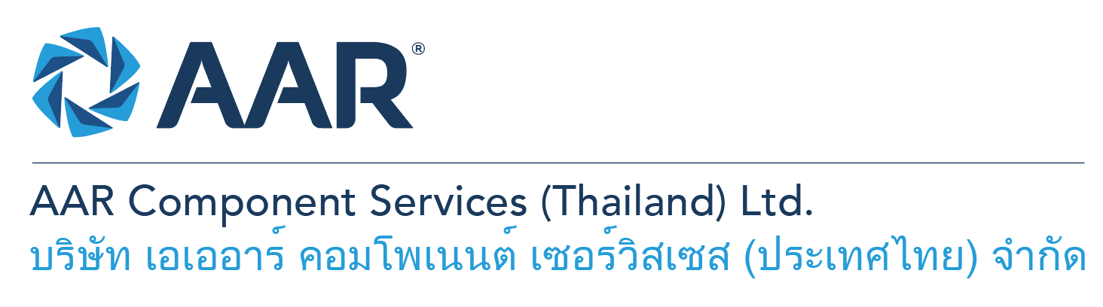

**PHP Web Developer**

**Quick AAR information / resources**

**Website:** [aarcorp.com](https://www.aarcorp.com/)

**Careers:** [aarcorp.com/careers](https://www.aarcorp.com/careers/)

**Email:** ACSTH-Recruitment@aarcorp.com

**The position**

**Key Roles & Responsibilities:**

* Write clean, well-designed PHP code (Zend Framework, WordPress).
* Develop and deploy new features to facilitate related procedures and

tools if necessary.

* Troubleshoot, test, and maintain the core product software and databases to ensure strong optimization and functionality.
* Contribute in all phases of the development of lifecycle.
* Follow industry best practices.
* Integrate user-facing elements developed by front-end developers.
* Build efficient, testable, and reusable PHP modules.
* Solve complex performance problems and architectural challenges.

**Qualifications:**

* Problem-Solving: I'm adept at breaking down complex problems,
* evaluating alternatives, and developing practical solutions. I can help with task planning, troubleshooting, and strategic thinking.
* Technical Expertise: I have knowledge spanning programming languages, software tools, and emerging technologies. I can write code, debug issues, and explain technical concepts in accessible ways.

**Total rewards**

As an AAR team member your rewards include:

* Annual uniform
* PPE safety equipment
* Transportation
* Vacation benefits, including Thai Public Holidays
* Provident Fund
* Group Insurance
* Training and development opportunities
* Staff engagement and recognition events

**Performance objectives**

* **Teamwork** – collaborates with colleagues to achieve results and is also comfortable working independently
* **Building trust** – operates with integrity, discloses own positions, remains open to ideas, and supports others through dignity, respect, and fairness
* **Building relationships and partnerships** – develops and leverages relationships within and across teams to achieve results
* **Communication** – conveys information and ideas clearly and concisely to individuals or group in an engaging manner, helping them understand and retain the message
* **Analytical skills** – must be able to use data to determine cause and effect for complex problem solving
* **Quality orientation** – accomplishes tasks by considering all areas involved, no matter how detailed

**Why should you apply?**

* AAR is the only aerospace / defense company on Forbes’ America’s Best Mid-Size Employers list.
* Our innovative and entrepreneurial culture encourages employee input in every aspect, from day-to-day activities to the company’s future growth.
* Our learning and career development program affords employees a learning path with the necessary tools and resources needed to help build their career at AAR.
* We support non-profits and organizations that work to improve society in four primary areas: veterans and active military; education with an emphasis on STEM; health and wellness; and diversity / inclusion.

**About AAR**

AAR is an awarded global aerospace and defense company that offers employees a long-term career pathway and the opportunity to work with a great team! At AAR, our people remain our priority! We create the #BestTeamInAviation by focusing on recruitment, training, growth, engagement, and retention. AAR employees are empowered to meet their individual professional development goals through our global learning and development program, mentorship program, leadership training, continued education, networking, and much more!

AAR is committed to building a diverse and inclusive workforce. We encourage applications from people of all races, ethnic origins, religions, abilities, sexual orientations, gender identities, or expressions. We are dedicated to the health and safety of our people, our customers, and the communities where we live and work.

**Primary Location**: 700/160 Amata City Chonburi Industrial Estate Moo1, T. Bankao, A. Pantong, Chonburi, 20160 Thailand.

Qualified applicants may email their resume to [ACSTH-Recruitment@aarcorp.com](mailto:ACSTH-Recruitment@aarcorp.com)

Please submit your resume in PDF format.

Although all applications are appreciated, only those candidates selected for an interview will be contacted.