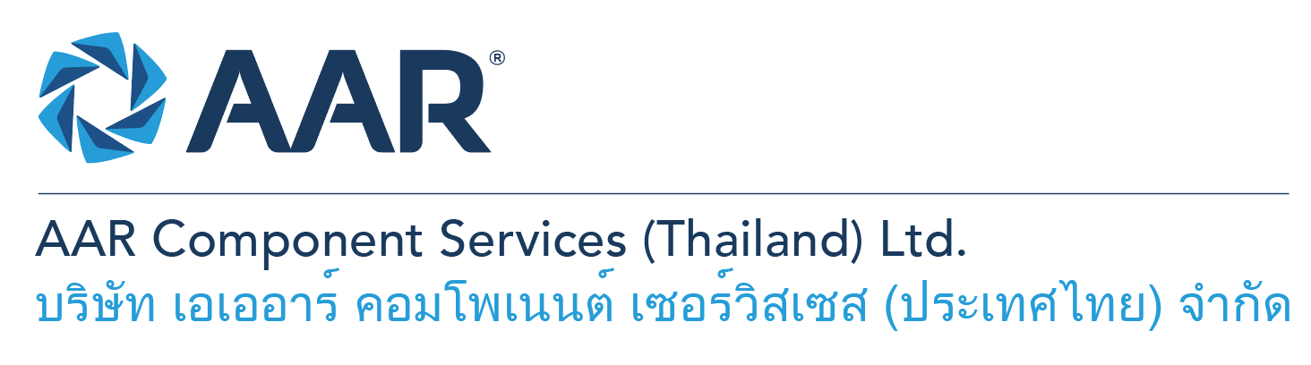

**NDT (Non-Destructive Testing) Inspectors**

**Quick AAR information / resources**

**Website:** [aarcorp.com](https://www.aarcorp.com/)

**Careers:** [aarcorp.com/careers](https://www.aarcorp.com/careers/)

**Email:** ACSTH-Recruitment@aarcorp.com

**The position**

We are looking for NDT (Non-Destructive Testing) Inspectors. The Technician performs and ensures safe and efficient work and troubleshooting on structures and components of various model of Aircraft, providing experience-based input and suggestions on improvements in support of continuous improvement. Daily operational work will be based on the principles of Lean Production.

**Key Roles & Responsibilities:**

* Responsible for performing NDT (FPI, MPI, ET, UT and IRT) with appropriate supervision on aircraft parts, components, nacelles, wheels, brakes, assemblies, or systems to verify no damage, cracks, or other visible or invisible imperfections affecting form, fit, function, or safety are present before or after repair operations.
* Uses equipment and testing techniques such as fluorescent penetrant inspection, magnetic penetrant inspection, eddy current machines, ultra-sonic testing equipment, thermography inspection, specialized and common tools.
* Set up and standardize equipment, process parts, interpret and evaluate for acceptance or rejection, and document results.
* Capable of developing work instructions from approved general procedures.
* Authorized to verify completed work was done in accordance with approved data, inspects and verifies other employees' work was done in accordance with approved data, and is authorized to inspect and certify parts are airworthy and release them for service per airworthiness authorities and regulations.

**Qualifications:**

* High Vocational Diploma in Production or Mechanical / Bachelor Degree in Engineering – Major in Mechanical or aerospace engineering or related.
* Having work experience in aerospace business, especially with focus on NDT skills (FPI, MPI, ET, UT and IRT).
* Capable of making key decision under pressure and meet requirements of the Aviation regulations.
* Capability to read and interpret mechanical drawings and work instructions
* Ability to read, write and understand English and computer literacy is required
* Able to read, interpret and understand SRM, CMM Manual, IPCs and/or specifications
* Able to read Technical data sheet and material safety data sheet.

**Total rewards**

As an AAR team member your rewards include:

* Annual uniform
* PPE safety equipment
* Transportation
* Vacation benefits, including Thai Public Holidays
* Provident Fund
* Group Insurance
* Training and development opportunities
* Staff engagement and recognition events

**Performance objectives**

* **Teamwork** – collaborates with colleagues to achieve results and is also comfortable working independently
* **Building trust** – operates with integrity, discloses own positions, remains open to ideas, and supports others through dignity, respect, and fairness
* **Building relationships and partnerships** – develops and leverages relationships within and across teams to achieve results
* **Communication** – conveys information and ideas clearly and concisely to individuals or group in an engaging manner, helping them understand and retain the message
* **Analytical skills** – must be able to use data to determine cause and effect for complex problem solving
* **Quality orientation** – accomplishes tasks by considering all areas involved, no matter how detailed

**Why should you apply?**

* AAR is the only aerospace / defense company on Forbes’ America’s Best Mid-Size Employers list.
* Our innovative and entrepreneurial culture encourages employee input in every aspect, from day-to-day activities to the company’s future growth.
* Our learning and career development program affords employees a learning path with the necessary tools and resources needed to help build their career at AAR.
* We support non-profits and organizations that work to improve society in four primary areas: veterans and active military; education with an emphasis on STEM; health and wellness; and diversity / inclusion.

**About AAR**

AAR is an awarded global aerospace and defense company that offers employees a long-term career pathway and the opportunity to work with a great team! At AAR, our people remain our priority! We create the #BestTeamInAviation by focusing on recruitment, training, growth, engagement, and retention. AAR employees are empowered to meet their individual professional development goals through our global learning and development program, mentorship program, leadership training, continued education, networking, and much more!

AAR is committed to building a diverse and inclusive workforce. We encourage applications from people of all races, ethnic origins, religions, abilities, sexual orientations, gender identities, or expressions. We are dedicated to the health and safety of our people, our customers, and the communities where we live and work.

**Primary Location**: 700/160 Amata City Chonburi Industrial Estate Moo1, T. Bankao, A. Pantong, Chonburi, 20160 Thailand.

Qualified applicants may email their resume to [ACSTH-Recruitment@aarcorp.com](mailto:ACSTH-Recruitment@aarcorp.com)

Please submit your resume in PDF format.

Although all applications are appreciated, only those candidates selected for an interview will be contacted.