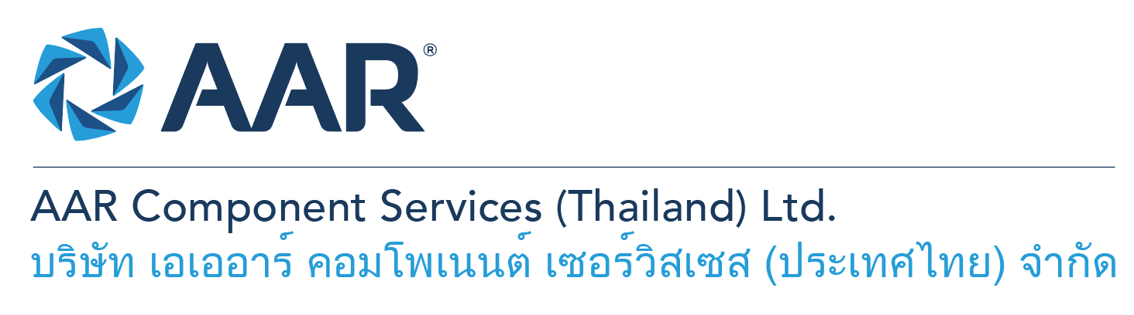

**Machining Technicians (General Repair)**

**Quick AAR information / resources**

**Website:** [aarcorp.com](https://www.aarcorp.com/)

**Careers:** [aarcorp.com/careers](https://www.aarcorp.com/careers/)

**Email:** ACSTH-Recruitment@aarcorp.com

**The position**

We are looking for Machining Technicians. The Technician performs and ensures safe and efficient work and troubleshooting on structures and components of various model of Aircraft, providing experience-based input and suggestions on improvements in support of continuous improvement. Daily operational work will be based on the principles of Lean Production.

**Key Roles & Responsibilities:**

* Perform disassembly, cleaning, inspection, repair and assembly on structures and components of various model of Aircraft IAW CMM, SRM, Engineering Instruction and approved technical data.
* Perform repairs (riveting/patching) of metallic parts IAW CMM, SRM, Engineering Instruction and approved technical data.
* Inspect aircraft parts / components IAW CMM, IPL/IPC, Service Bulletin, Service Letter, Airworthiness Directive and SRM
* Read and interpret technical manuals, mechanical drawings and process sheets and follow their procedures/instructions in English.
* Prepare work packages and routings for assigned SROs

**Qualifications:**

* High vocational diploma or equivalent background and related experience in mechanical or automotive.
* Must be capable of reading and interpreting, technical manuals (SRM, CMM or IPC), mechanical drawings, work instructions, process sheet, and other related materials (English).
* Hands-on skills in using of common hand tools and measuring equipment
* Ability to read, write and understand English and computer literacy is required
* Personal computer skills including Microsoft Office, especially Excel and Word.
* Must possess basic English language verbal and written communication skills.
* Ability to lift at least 20 kilograms.
* Ability to work shift, overtime, and weekends as required.
* Experience work on repair process such as general, welding, machining and NDT inspection.
* Use basic machines such as Lathe, Mill, Drill, Grinder (manual and CNC, CAD/CAM) in machine shop
* Strong communication and interpersonal skills.
* Good troubleshooting skills.

**Total rewards**

As an AAR team member your rewards include:

* Annual uniform
* PPE safety equipment
* Transportation
* Vacation benefits, including Thai Public Holidays
* Provident Fund
* Group Insurance
* Training and development opportunities
* Staff engagement and recognition events

**Performance objectives**

* **Teamwork** – collaborates with colleagues to achieve results and is also comfortable working independently
* **Building trust** – operates with integrity, discloses own positions, remains open to ideas, and supports others through dignity, respect, and fairness
* **Building relationships and partnerships** – develops and leverages relationships within and across teams to achieve results
* **Communication** – conveys information and ideas clearly and concisely to individuals or group in an engaging manner, helping them understand and retain the message
* **Analytical skills** – must be able to use data to determine cause and effect for complex problem solving
* **Quality orientation** – accomplishes tasks by considering all areas involved, no matter how detailed

**Why should you apply?**

* AAR is the only aerospace / defense company on Forbes’ America’s Best Mid-Size Employers list.
* Our innovative and entrepreneurial culture encourages employee input in every aspect, from day-to-day activities to the company’s future growth.
* Our learning and career development program affords employees a learning path with the necessary tools and resources needed to help build their career at AAR.
* We support non-profits and organizations that work to improve society in four primary areas: veterans and active military; education with an emphasis on STEM; health and wellness; and diversity / inclusion.

**About AAR**

AAR is an awarded global aerospace and defense company that offers employees a long-term career pathway and the opportunity to work with a great team! At AAR, our people remain our priority! We create the #BestTeamInAviation by focusing on recruitment, training, growth, engagement, and retention. AAR employees are empowered to meet their individual professional development goals through our global learning and development program, mentorship program, leadership training, continued education, networking, and much more!

AAR is committed to building a diverse and inclusive workforce. We encourage applications from people of all races, ethnic origins, religions, abilities, sexual orientations, gender identities, or expressions. We are dedicated to the health and safety of our people, our customers, and the communities where we live and work.

**Primary Location**: 700/160 Amata City Chonburi Industrial Estate Moo1, T. Bankao, A. Pantong, Chonburi, 20160 Thailand.

Qualified applicants may email their resume to [ACSTH-Recruitment@aarcorp.com](mailto:ACSTH-Recruitment@aarcorp.com)

Please submit your resume in PDF format.

Although all applications are appreciated, only those candidates selected for an interview will be contacted.