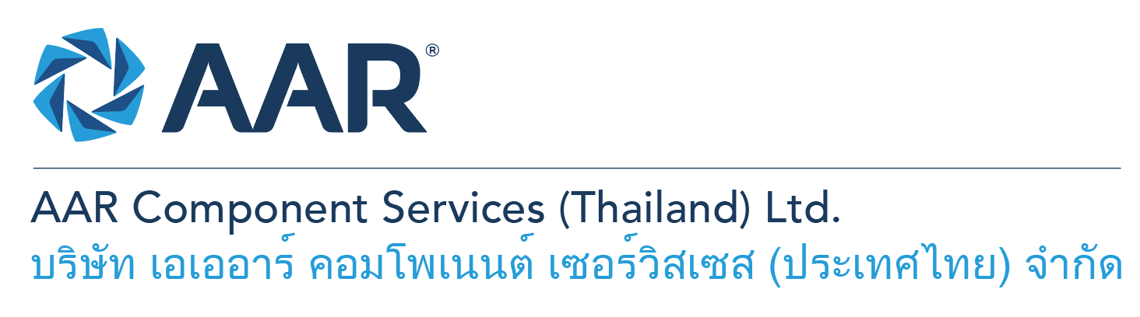

**IT & System Analyst**

**Quick AAR information / resources**

**Website:** [aarcorp.com](https://www.aarcorp.com/)

**Careers:** [aarcorp.com/careers](https://www.aarcorp.com/careers/)

**Email:** ACSTH-Recruitment@aarcorp.com

**The position**

* Provide day-to-day support related ERP, Business reporting issues.
* Troubleshooting and resolve technical issues with ERP, Intranet, WMS, Shop floor software system.
* Configuring and maintaining server such as ERP, Database, PHP Web.
* Developing, customizing and coding form and report in ERP application, Intranet.

**Key Roles & Responsibilities:**

* ERP Syteline modules overview
* ERP Syteline Development, form, IDO, object (Service Order)
* MS.SQL – Administration, Command, Design
* SSRS or Crystal Report - Designing and developing
* Web Technology, Apache, IIS, WordPress - Design and developing (PHP)
* Helpdesk ERP, software and application day-to-day support ticket
* Internal Control Compliance and Enforcement, SOX
* Converting business requirements to IT applications
* Coordinate with Corporation in other regions
* Enforcement IT systems to comply IT procedures
* Ad -hoc request by Supervisors
* Business process improvement
* ERP application user training

**Qualifications:**

* Bachelor's degree in IT, Engineering, or related field
* Experience with INFOR SyteLine customization
* Visual basic, C#, .NET, MS.SQL, SSRS, Crystal Report
* API with SyteLine
* PHP

**Total rewards**

As an AAR team member your rewards include:

* Annual uniform
* PPE safety equipment
* Transportation
* Vacation benefits, including Thai Public Holidays
* Provident Fund
* Group Insurance
* Training and development opportunities
* Staff engagement and recognition events

**Performance objectives**

* **Teamwork** – collaborates with colleagues to achieve results and is also comfortable working independently
* **Building trust** – operates with integrity, discloses own positions, remains open to ideas, and supports others through dignity, respect, and fairness
* **Building relationships and partnerships** – develops and leverages relationships within and across teams to achieve results
* **Communication** – conveys information and ideas clearly and concisely to individuals or group in an engaging manner, helping them understand and retain the message
* **Analytical skills** – must be able to use data to determine cause and effect for complex problem solving
* **Quality orientation** – accomplishes tasks by considering all areas involved, no matter how detailed

**Why should you apply?**

* AAR is the only aerospace / defense company on Forbes’ America’s Best Mid-Size Employers list.
* Our innovative and entrepreneurial culture encourages employee input in every aspect, from day-to-day activities to the company’s future growth.
* Our learning and career development program affords employees a learning path with the necessary tools and resources needed to help build their career at AAR.
* We support non-profits and organizations that work to improve society in four primary areas: veterans and active military; education with an emphasis on STEM; health and wellness; and diversity / inclusion.

**About AAR**

AAR is an awarded global aerospace and defense company that offers employees a long-term career pathway and the opportunity to work with a great team! At AAR, our people remain our priority! We create the #BestTeamInAviation by focusing on recruitment, training, growth, engagement, and retention. AAR employees are empowered to meet their individual professional development goals through our global learning and development program, mentorship program, leadership training, continued education, networking, and much more!

AAR is committed to building a diverse and inclusive workforce. We encourage applications from people of all races, ethnic origins, religions, abilities, sexual orientations, gender identities, or expressions. We are dedicated to the health and safety of our people, our customers, and the communities where we live and work.

**Primary Location**: 700/160 Amata City Chonburi Industrial Estate Moo1, T. Bankao, A. Pantong, Chonburi, 20160 Thailand.

Qualified applicants may email their resume to [ACSTH-Recruitment@aarcorp.com](mailto:ACSTH-Recruitment@aarcorp.com)

Please submit your resume in PDF format.

Although all applications are appreciated, only those candidates selected for an interview will be contacted.