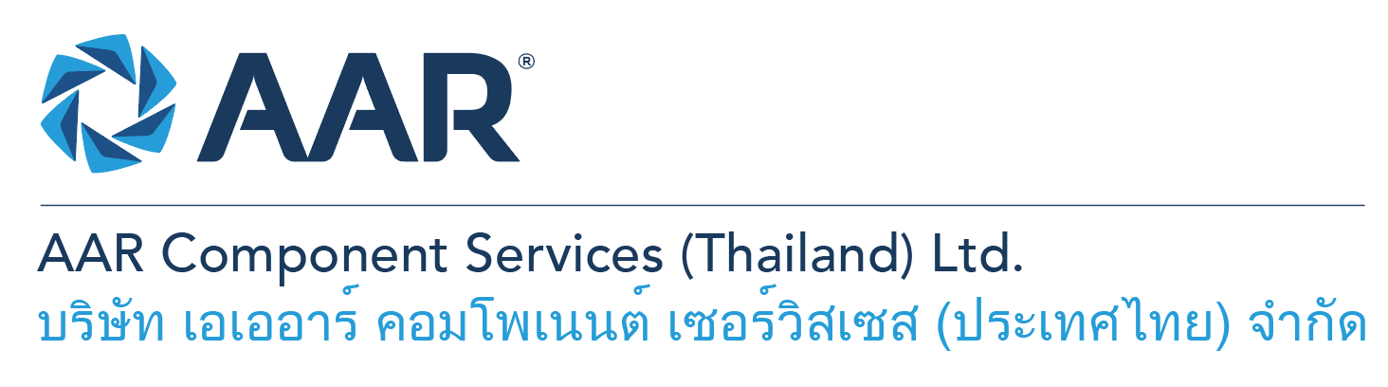

**Quick AAR information / resources**

**Website:** [aarcorp.com](https://www.aarcorp.com/)

**Careers:** [aarcorp.com/careers](https://www.aarcorp.com/careers/)

**Email:** ACSTH-Recruitment@aarcorp.com

**Aviation Repair Design Engineers**

**The position**

We are looking for Aviation Repair Design Engineers to be responsible for Design Engineering activities related to product lines.

**Key Roles & Responsibilities:**

* Understand and interpret data as provided in the OEM manuals.
* Perform repair design activities across various disciplines including but not limited to Metallurgy Composite Materials, Machining, and welding.
* Liaise with FAA DERs to obtain approval for repair designs.
* Supporting the Compliance Verification Engineers (CVE) and Designated Airworthiness Representatives (DER) by Demonstrating compliances for large aircraft component repairs.
* Provide technical support for routine shop-floor operations with reference to standard industrial best practices.
* Provide technical support to the Business Development and Marketing teams to ensure business competence.
* Provide technical support to the QA department and assist with Investigations of quality escapes, warranty claims, and corrective actions.
* Provide technical support to the Customer Services team to ensure effective communication between stakeholders.
* Develops creative and innovative structural repair solutions improving maintainability, and reparability of nacelles structures.
* Support customer service requests with development of technical dispositions, instructions, and designs for damage allowance/treatment and deviations to nacelles structures design and repairs (Inlets, Fan Cowls, Thrust Reverser/Core Cowls, and Exhausts).
* Continuous Improvement Champion / Lead for Design Engineering Department.

**Qualifications:**

* Bachelor's degree, Aeronautical Engineering or Mechanical Engineering or Equivalent.
* Must have experience on Aircraft Structural repair design with FAA DER or EASA DOA approvals for 3 years minimum.
* Knowledge of the Aviation Regulations (CS and FAR) and Basic knowledge of EASA Part 21.
* Proficient in creation of Engineering Drawings using CAD software.
* Proficiency in Engineering software such as MS Office, CATIA, Solid works and finite element analysis.
* Excellent command in read, written, listening, and spoken English.
* Must have following specific competencies:
* Metallurgical Science
* Proficient to create CAD file from 3D scan cloud data and Reverse Engineering Process
* Structural Repair Design

**Total rewards**

As an AAR team member your rewards include:

* Annual uniform
* PPE safety equipment
* Transportation
* Vacation benefits, including Thai Public Holidays
* Provident Fund
* Group Insurance
* Training and development opportunities
* Staff engagement and recognition events

**Performance objectives**

* **Teamwork** – collaborates with colleagues to achieve results and is also comfortable working independently
* **Building trust** – operates with integrity, discloses own positions, remains open to ideas, and supports others through dignity, respect, and fairness
* **Building relationships and partnerships** – develops and leverages relationships within and across teams to achieve results
* **Communication** – conveys information and ideas clearly and concisely to individuals or group in an engaging manner, helping them understand and retain the message
* **Analytical skills** – must be able to use data to determine cause and effect for complex problem solving
* **Quality orientation** – accomplishes tasks by considering all areas involved, no matter how detailed

**Why should you apply?**

* AAR is the only aerospace / defense company on Forbes’ America’s Best Mid-Size Employers list.
* Our innovative and entrepreneurial culture encourages employee input in every aspect, from day-to-day activities to the company’s future growth.
* Our learning and career development program affords employees a learning path with the necessary tools and resources needed to help build their career at AAR.
* We support non-profits and organizations that work to improve society in four primary areas: veterans and active military; education with an emphasis on STEM; health and wellness; and diversity / inclusion.

**About AAR**

AAR is an awarded global aerospace and defense company that offers employees a long-term career pathway and the opportunity to work with a great team! At AAR, our people remain our priority! We create the #BestTeamInAviation by focusing on recruitment, training, growth, engagement, and retention. AAR employees are empowered to meet their individual professional development goals through our global learning and development program, mentorship program, leadership training, continued education, networking, and much more!

AAR is committed to building a diverse and inclusive workforce. We encourage applications from people of all races, ethnic origins, religions, abilities, sexual orientations, gender identities, or expressions. We are dedicated to the health and safety of our people, our customers, and the communities where we live and work.

**Primary Location**: 700/160 Amata City Chonburi Industrial Estate Moo1, T. Bankao, A. Pantong, Chonburi, 20160 Thailand.

Qualified applicants may email their resume to [ACSTH-Recruitment@aarcorp.com](mailto:ACSTH-Recruitment@aarcorp.com)

Please submit your resume in PDF format.

Although all applications are appreciated, only those candidates selected for an interview will be contacted.