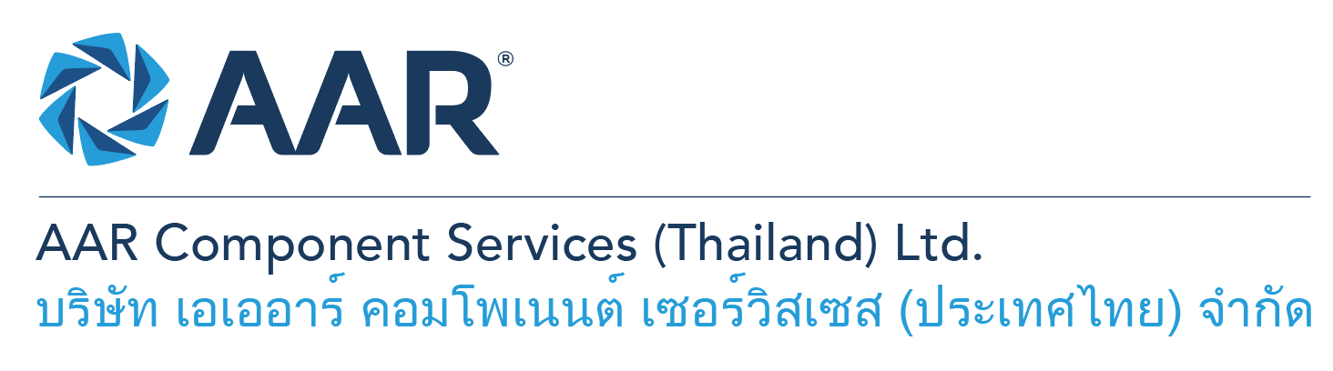

**Aviation Evaluators / Inspectors**

**Quick AAR information / resources**

**Website:** [aarcorp.com](https://www.aarcorp.com/)

**Careers:** [aarcorp.com/careers](https://www.aarcorp.com/careers/)

**Email:** ACSTH-Recruitment@aarcorp.com

**The position**

We are looking for Aviation Evaluators / Inspectors. Evaluators is responsible for performing inspections IAW CMM, SRM, Drawings and approved data, preparation of discrepancy reports for submission to customers and input of required materials in MRP system to suit customer requirements. Daily operational work will be based on the principles of Lean Production.

**Key Roles & Responsibilities:**

* Perform receiving inspection of aircraft components
* Attend meetings to obtain work scope required IAW customer repair orders and/or requirements.
* Convert customer agreement/contract/proposal into working SRO DR reports
* Communicate & coordinate with Mechanical and Cleaning Technicians for works required.
* Inspect aircraft parts / components IAW CMM, IPL/IPC, Service Bulletin, Service Letter, Airworthiness Directive and SRM
* Justify serviceable parts against CMM and/or Aviation Industry Standards
* Make repair/replace decisions associated with cost reduction and quality
* Prepare work packages and routings for assigned SROs
* Create DR worksheet (Discrepancy Report) to address and conform with customer requirements
* Perform SB check list (Previous complied, Comply with, and not applicable)
* Raise REA to Design engineers for repair materials and repair instruction of damages beyond repairable limits per CMM and SRM.
* Create BOM (Bill of Materials) and demand in MRP system (Syteline)
* Coordinate with Production and Design Engineering for work/repair instruction and routings
* Coordinate with APL, MAC, and Supply Chain for repair processes and outside process
* Separate serviceable, repairable, scrapped parts and write identification tags (Green, Yellow and Red tags)
* Visualize findings using Visual Control Method
* Coordinate with CRM for chargeable and non-chargeable items against customer agreement/contract/proposal
* Perform cross-checks with other evaluators
* Summarize DR worksheet and routings to Mechanical Technicians, Bonders and Paint Technicians

**Qualifications:**

* Diploma with minimum 2 years experiences or Bachelor’s Degree –Mechanics / Aerospace Engineering or Related
* Operational understanding and troubleshooting skills
* Capability to read and interpret mechanical drawings and work instructions
* Ability to read, write and understand English and computer literacy is required
* Able to read, interpret and understand SRM, CMM Manual, IPCs
* Hands-on skills in using of common hand tools and measuring equipment
* Proficiency in computer skills and Microsoft Suite (MS Word, Office, Excel)
* Able to coordinate and work well with others (i.e. Production and Design Engineers, Planners/Buyers)

**Total rewards**

As an AAR team member your rewards include:

* Annual uniform
* PPE safety equipment
* Transportation
* Vacation benefits, including Thai Public Holidays
* Provident Fund
* Group Insurance
* Training and development opportunities
* Staff engagement and recognition events

**Performance objectives**

* **Teamwork** – collaborates with colleagues to achieve results and is also comfortable working independently
* **Building trust** – operates with integrity, discloses own positions, remains open to ideas, and supports others through dignity, respect, and fairness
* **Building relationships and partnerships** – develops and leverages relationships within and across teams to achieve results
* **Communication** – conveys information and ideas clearly and concisely to individuals or group in an engaging manner, helping them understand and retain the message
* **Analytical skills** – must be able to use data to determine cause and effect for complex problem solving
* **Quality orientation** – accomplishes tasks by considering all areas involved, no matter how detailed

**Why should you apply?**

* AAR is the only aerospace / defense company on Forbes’ America’s Best Mid-Size Employers list.
* Our innovative and entrepreneurial culture encourages employee input in every aspect, from day-to-day activities to the company’s future growth.
* Our learning and career development program affords employees a learning path with the necessary tools and resources needed to help build their career at AAR.
* We support non-profits and organizations that work to improve society in four primary areas: veterans and active military; education with an emphasis on STEM; health and wellness; and diversity / inclusion.

**About AAR**

AAR is an awarded global aerospace and defense company that offers employees a long-term career pathway and the opportunity to work with a great team! At AAR, our people remain our priority! We create the #BestTeamInAviation by focusing on recruitment, training, growth, engagement, and retention. AAR employees are empowered to meet their individual professional development goals through our global learning and development program, mentorship program, leadership training, continued education, networking, and much more!

AAR is committed to building a diverse and inclusive workforce. We encourage applications from people of all races, ethnic origins, religions, abilities, sexual orientations, gender identities, or expressions. We are dedicated to the health and safety of our people, our customers, and the communities where we live and work.

**Primary Location**: 700/160 Amata City Chonburi Industrial Estate Moo1, T. Bankao, A. Pantong, Chonburi, 20160 Thailand.

Qualified applicants may email their resume to [ACSTH-Recruitment@aarcorp.com](mailto:ACSTH-Recruitment@aarcorp.com)

Please submit your resume in PDF format.

Although all applications are appreciated, only those candidates selected for an interview will be contacted.