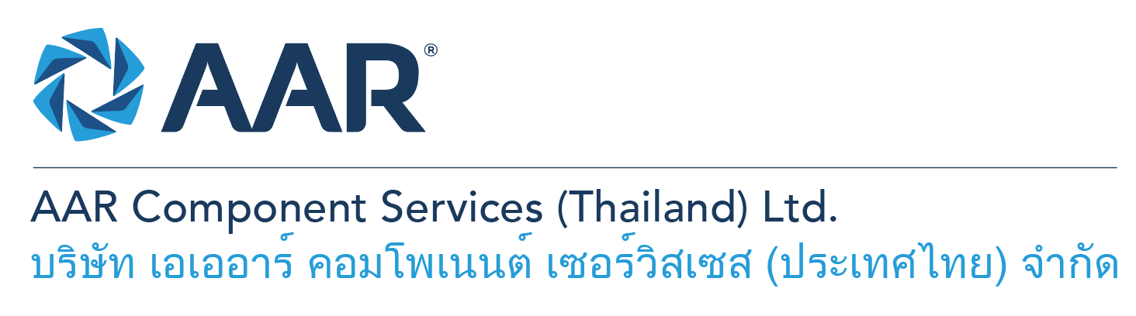

**Aircraft Component Release to Service (RTS)**

**Quick AAR information / resources**

**Website:** [aarcorp.com](https://www.aarcorp.com/)

**Careers:** [aarcorp.com/careers](https://www.aarcorp.com/careers/)

**Email:** ACSTH-Recruitment@aarcorp.com

**The position**

We are looking for Aircraft Component Release to Service (RTS). RTS is responsible for performing inspections IAW CMM, SRM, Drawings and approved data, preparation of discrepancy reports for submission to customers and input of required materials in MRP system to suit customer requirements. Daily operational work will be based on the principles of Lean Production.

**Key Roles & Responsibilities:**

* Perform FAA and EASA AD check and verify applicable and complied to SROs.
* Quarterly update AD check list from FAA and EASA websites and QA releases.
* Verify the part number of the units against required capability lists and feedback to customer service if the part number is not on our capability list.
* Verify DR reports to ensure all customer requirements are met and addressed.
* Perform receiving and final out parts check for outgoing process.
* Perform final-out inspection of aircraft components prior to releasing to service.
* Perform in process inspection as a back-up of PLIs to ensure the repair or assembly processes have been done IAW approved data.
* Perform random check as witness for in process inspection.
* Check maintenance record (routings and DR reports) and objective evidences (curing chart, curing parameter, ply orientation, paint thickness, heat treatment chart, etc.) to ensure all requirements in approved data are met.
* Check and ensure the completion and correction of maintenance records IAW FAA, EASA and other required authority regulation.
* Support warranty investigation report, root cause identification, corrective actions and preventive actions.
* Identify Critical To Quality items (tools, material, knowledge and process) and work with production engineer to minimize the risk to quality escape.
* Support Cost of Poor Quality (COPQ) reduction (identification, analysis, action, and verification)
* Perform cross-checks with evaluators as requested to ensure all defects are addressed.
* Ensure product quality to meet all requirements for FAA, EASA, CAAC and other standards with customer satisfaction

**Qualifications:**

* Diploma or Bachelor’s Degree –Mechanics / Aerospace Engineering or Related
* Operational understanding and troubleshooting skills
* Capability to read and interpret mechanical drawings and work instructions
* Ability to read, write and understand English and computer literacy is required
* Able to read, interpret and understand SRM, CMM Manual, IPCs
* Hands-on skills in using of common hand tools and measuring equipment
* Willingness to work shifts/weekends when needed
* Proficiency in computer skills and Microsoft Suite (MS Word, Office, Excel)
* Able to coordinate and work well with others (i.e. Team Leaders, Engineers, Planners/Buyers)

**Total rewards**

As an AAR team member your rewards include:

* Annual uniform
* PPE safety equipment
* Transportation
* Vacation benefits, including Thai Public Holidays
* Provident Fund
* Group Insurance
* Training and development opportunities
* Staff engagement and recognition events

**Performance objectives**

* **Teamwork** – collaborates with colleagues to achieve results and is also comfortable working independently
* **Building trust** – operates with integrity, discloses own positions, remains open to ideas, and supports others through dignity, respect, and fairness
* **Building relationships and partnerships** – develops and leverages relationships within and across teams to achieve results
* **Communication** – conveys information and ideas clearly and concisely to individuals or group in an engaging manner, helping them understand and retain the message
* **Analytical skills** – must be able to use data to determine cause and effect for complex problem solving
* **Quality orientation** – accomplishes tasks by considering all areas involved, no matter how detailed

**Why should you apply?**

* AAR is the only aerospace / defense company on Forbes’ America’s Best Mid-Size Employers list.
* Our innovative and entrepreneurial culture encourages employee input in every aspect, from day-to-day activities to the company’s future growth.
* Our learning and career development program affords employees a learning path with the necessary tools and resources needed to help build their career at AAR.
* We support non-profits and organizations that work to improve society in four primary areas: veterans and active military; education with an emphasis on STEM; health and wellness; and diversity / inclusion.

**About AAR**

AAR is an awarded global aerospace and defense company that offers employees a long-term career pathway and the opportunity to work with a great team! At AAR, our people remain our priority! We create the #BestTeamInAviation by focusing on recruitment, training, growth, engagement, and retention. AAR employees are empowered to meet their individual professional development goals through our global learning and development program, mentorship program, leadership training, continued education, networking, and much more!

AAR is committed to building a diverse and inclusive workforce. We encourage applications from people of all races, ethnic origins, religions, abilities, sexual orientations, gender identities, or expressions. We are dedicated to the health and safety of our people, our customers, and the communities where we live and work.

**Primary Location**: 700/160 Amata City Chonburi Industrial Estate Moo1, T. Bankao, A. Pantong, Chonburi, 20160 Thailand.

Qualified applicants may email their resume to [ACSTH-Recruitment@aarcorp.com](mailto:ACSTH-Recruitment@aarcorp.com)

Please submit your resume in PDF format.

Although all applications are appreciated, only those candidates selected for an interview will be contacted.