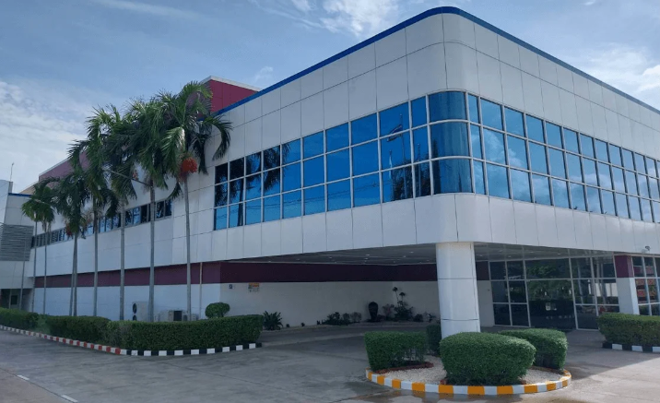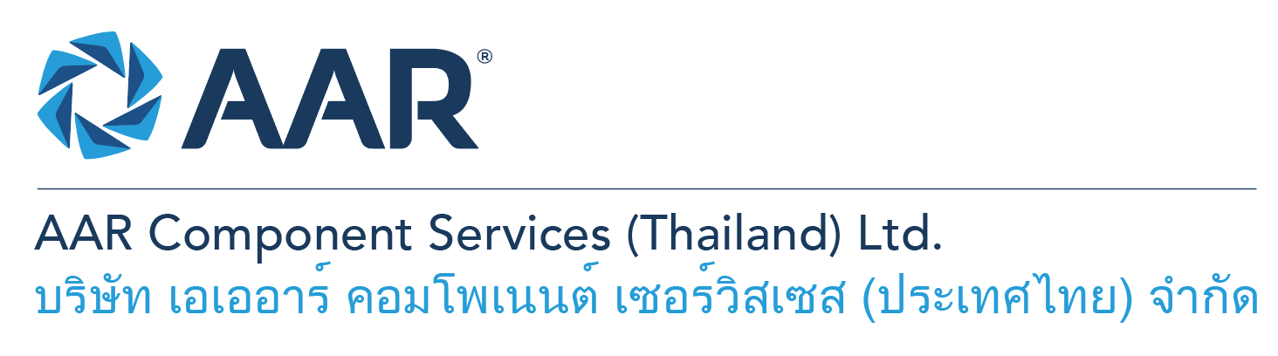

**Quick AAR information / resources**

**Website:** [aarcorp.com](https://www.aarcorp.com/)

**Careers:** [aarcorp.com/careers](https://www.aarcorp.com/careers/)

**Email:** ACSTH-Recruitment@aarcorp.com

**Aircraft Component and Accessories Technicians**

**The position**

We are looking for Aircraft Component and Accessories Technicians. The Technician performs and ensures safe and efficient work and troubleshooting on Aircraft components (Accessory, Heat exchanger, Wheels and Brakes) of various model of Aircraft, providing experience-based input and suggestions on improvements in support of continuous improvement. Daily operational work will be based on the principles of Lean Production.

**Key Roles & Responsibilities:**

* Perform testing, disassembly, cleaning, inspection, repair and assembly on Aircraft components of various model of Aircraft.
* Coordinate with customer service team for approval of the job and manage the job’s replacement parts.
* Coordinate with the store for parts pick-up.
* Perform analytical inspection using the latest inspection tooling as well as using visual inspection guides.
* Perform Maintenance and repair with chemicals, tools and equipment such as Hand finishing, Painting or Cutting on aerospace part and assemblies IAW CMM, SRM, Engineering Instruction and approved technical data.
* Completes all required paperwork and documentation in timely manner after task complete.
* Read, interpret, and properly employ technical manuals, mechanical drawing.
* Perform daily tooling check, preventative maintenance check of the responsible equipment/toolboxes/chemical cabinets/machines.

**Qualifications:**

* Bachelor's degree in engineering or relate field (Aerospace, industrial, mechanical, mechatronics, or another suitable field) 0-2 years experiences.
* Diploma from high vocational institute in Mechanical or Aerospace or relate field with minimum 3-5 years experiences of maintenance tasks in MRO business.
* Able to read, interpret and understand drawings, SRM, CMM Manual, IPCs and/or Specification.
* Ability to read, write and understand English and computer literacy is required.
* Hands-on skill with hand tools and measuring equipment.
* Ability to work shift, overtime, and weekends as required.
* Strong communication and interpersonal skills. Toeic scores >400

**Total rewards**

As an AAR team member your rewards include:

* Annual uniform
* PPE safety equipment
* Transportation
* Vacation benefits, including Thai Public Holidays
* Provident Fund
* Group Insurance
* Training and development opportunities
* Staff engagement and recognition events

**Performance objectives**

* **Teamwork** – collaborates with colleagues to achieve results and is also comfortable working independently
* **Building trust** – operates with integrity, discloses own positions, remains open to ideas, and supports others through dignity, respect, and fairness
* **Building relationships and partnerships** – develops and leverages relationships within and across teams to achieve results
* **Communication** – conveys information and ideas clearly and concisely to individuals or group in an engaging manner, helping them understand and retain the message
* **Analytical skills** – must be able to use data to determine cause and effect for complex problem solving
* **Quality orientation** – accomplishes tasks by considering all areas involved, no matter how detailed

**Why should you apply?**

* AAR is the only aerospace / defense company on Forbes’ America’s Best Mid-Size Employers list.
* Our innovative and entrepreneurial culture encourages employee input in every aspect, from day-to-day activities to the company’s future growth.
* Our learning and career development program affords employees a learning path with the necessary tools and resources needed to help build their career at AAR.
* We support non-profits and organizations that work to improve society in four primary areas: veterans and active military; education with an emphasis on STEM; health and wellness; and diversity / inclusion.

**About AAR**

AAR is an awarded global aerospace and defense company that offers employees a long-term career pathway and the opportunity to work with a great team! At AAR, our people remain our priority! We create the #BestTeamInAviation by focusing on recruitment, training, growth, engagement, and retention. AAR employees are empowered to meet their individual professional development goals through our global learning and development program, mentorship program, leadership training, continued education, networking, and much more!

AAR is committed to building a diverse and inclusive workforce. We encourage applications from people of all races, ethnic origins, religions, abilities, sexual orientations, gender identities, or expressions. We are dedicated to the health and safety of our people, our customers, and the communities where we live and work.

**Primary Location**: 700/160 Amata City Chonburi Industrial Estate Moo1, T. Bankao, A. Pantong, Chonburi, 20160 Thailand.

Qualified applicants may email their resume to [ACSTH-Recruitment@aarcorp.com](mailto:ACSTH-Recruitment@aarcorp.com)

Please submit your resume in PDF format.

Although all applications are appreciated, only those candidates selected for an interview will be contacted.